Alzheimer's Disease Detection

Using Deep Learning

Domain: Healthcare / Medical Image Classification
Dataset: OASIS Alzheimer's MRI (86,437 images)
Best Model: MobileNetV2 (Fine-Tuned) - 99.47% Accuracy
Platform: Google Colab (T4 GPU) + Flask Web Application
Date: April 2026

Table of Contents
1. Project Overview
2. Problem Statement & Purpose
3. Dataset Description
4. Data Splitting & Augmentation
5. Experiment 1 - Initial Model Comparison
6. Experiment 2 - Fine-Tuned MobileNetV2
7. Performance Metrics
8. Technologies Used
9. Web Application
10. Conclusion
11. References

1. Project Overview
This project is an end-to-end Alzheimer's disease detection system that uses deep learning models trained on brain MRI scans to classify the severity of Alzheimer's disease into four stages. The system includes a full machine learning pipeline for model training on Google Colab (T4 GPU) and a professional Flask web application for real-time prediction with clinical context.

Project Title | Alzheimer's Disease Detection System
Domain | Healthcare / Medical Image Classification
Technique | Deep Learning (CNNs & Transfer Learning)
Language | Python 3.12
Framework | TensorFlow 2.19 / Keras
Web App | Flask + SQLite + Bootstrap 5
Training | Google Colab with NVIDIA T4 GPU
Best Accuracy | 99.47% (MobileNetV2 Fine-Tuned)

2. Problem Statement & Purpose

What is the Project?
This project develops an AI-powered system that can analyze brain MRI (Magnetic Resonance Imaging) scans and classify them into one of four stages of Alzheimer's disease progression: Non Demented, Very Mild Demented, Mild Demented, and Moderate Demented.

Why am I Doing It?
- Alzheimer's disease affects over 55 million people worldwide. Early and accurate detection is critical.
- Manual diagnosis by radiologists is time-intensive, subjective, and prone error based on the observer.
- AI-assisted detection can serve as a second opinion tool, improving diagnostic accuracy.
- The distinction between early stages is extremely subtle on MRI, making it ideal for deep learning.

What is the Purpose?
- Build a multi-class image classifier across four Alzheimer's stages.
- Compare 6 different deep learning architectures (CNN, MLP, VGG16, ResNet50, EfficientNetB0, MobileNetV2).
- Deploy the best model in a user-friendly web application with clinical context.

How Did I Do It?
- Collected the OASIS brain MRI dataset (86,437 images across 4 classes).
- Cleaned the data - validated all images, removed corrupted/duplicate files.
- Split the data into Train (70%), Validation (15%), Test (15%) with stratification.
- Applied data augmentation and computed class weights for imbalance handling.
- Trained 6 different models on Google Colab with a T4 GPU.
- Identified MobileNetV2 as the best base architecture.
- Fine-tuned MobileNetV2 with 224x224 input and partial backbone unfreezing - achieved 99.47% accuracy.
- Built a Flask web application with user auth, upload, prediction, and clinical results.

3. Dataset Description
The dataset used is the OASIS (Open Access Series of Imaging Studies) Alzheimer's Detection Dataset, sourced from Kaggle (ninadaithal/imagesoasis). It contains 86,437 labeled brain MRI scan images distributed across 4 classes. The dataset exhibits severe class imbalance, with 'Non Demented' having 138x more samples than 'Moderate Dementia'.

Class | Images | Share (%) | Train | Test
Mild Dementia | 5,002 | 5.79% | 3,501 | 751
Moderate Dementia | 488 | 0.56% | 342 | 73
Non Demented | 67,222 | 77.77% | 47,055 | 10,083
Very Mild Dementia | 13,725 | 15.88% | 9,607 | 2,059
TOTAL | 86,437 | 100% | 60,505 | 12,966

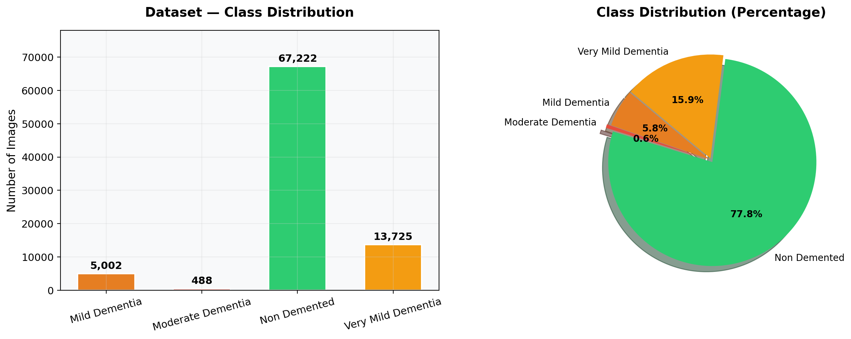

4. Data Splitting & Augmentation
The dataset was split using stratified sampling to maintain class proportions: 70% for training (60,505 images), 15% for validation (12,966), and 15% for testing (12,966). Real-time data augmentation was applied during training to improve generalization.
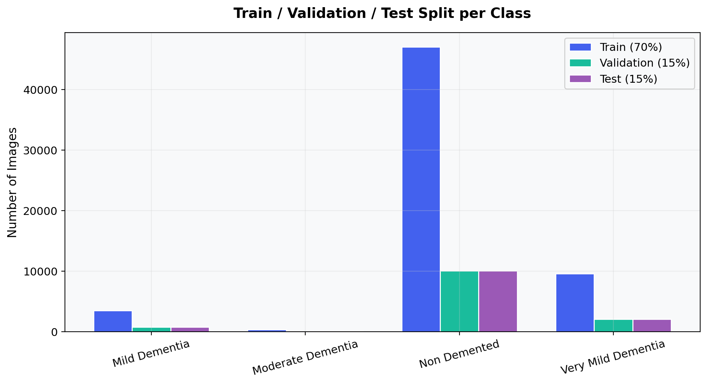

Augmentation Parameters
Parameter | Experiment 1 | Experiment 2 (Fine-Tuned)
Rotation | 20 degrees | 10 degrees
Zoom | 20% | 10%
Horizontal Flip | Yes | No (MRI-specific)
Shear | 20% | 10%
Normalization | 1/255 | 1/255

Class Weights
Moderate Dementia | 73 | 44.2
Mild Dementia | 751 | 4.3
Very Mild Dementia | 2,059 | 1.6
Non-Demented | 10,083 | 0.3

5. Experiment 1 - Initial Model Comparison
Training for all six models was conducted on Kaggle notebooks using smaller 128×128 images, with all pretrained layers frozen so that only the classification head was trained. Data augmentation was more aggressive, including horizontal flipping, a rotation range of ±20°, and a zoom range of 20%. No EarlyStopping or learning rate scheduling was applied. The models were trained using the Adam optimizer (learning rate = 1e-4) for 20 epochs. Under these settings, only transfer learning models with sufficiently strong feature extraction capabilities achieved meaningful accuracy.

Model | Test Accuracy | Weighted F1 | Macro F1 | Status
MobileNetV2 | 75.27% | 0.78 | 0.63 | Best
VGG16 | 69.10% | 0.73 | 0.44 | Moderate
ResNet50 | 47.29% | 0.56 | 0.26 | Poor
Custom CNN | 0.56% | 0.00 | 0.00 | Failed
MLP | 0.56% | 0.00 | 0.00 | Failed
EfficientNetB0 | 0.56% | 0.00 | 0.00 | Failed

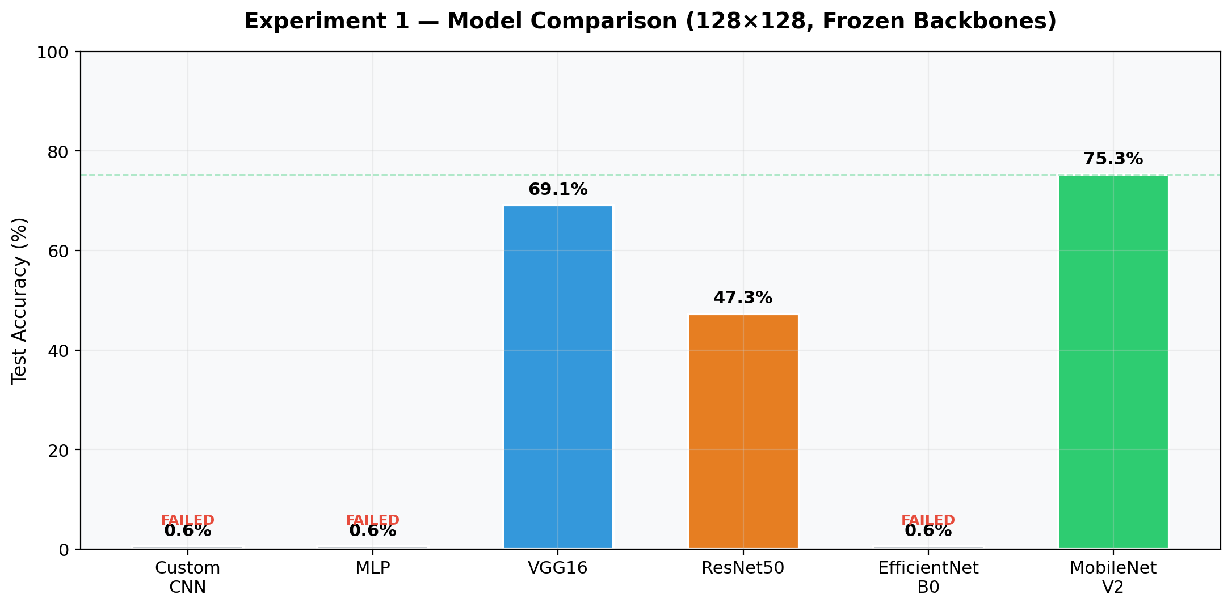

6. Experiment 2 - Fine-Tuned MobileNetV2 (224x224)
Based on Experiment 1 results, MobileNetV2 was selected for fine-tuning with higher resolution input (224x224), partial backbone unfreezing (last 30 layers trainable), lower learning rate (1e-4), and MRI-specific augmentation (no horizontal flip). This achieved 99.47% test accuracy.
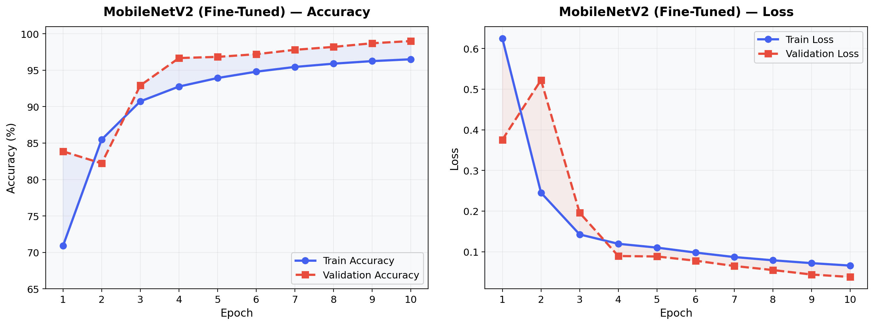

7. Performance Metrics

Classification Report - MobileNetV2 (Fine-Tuned)
Overall Test Accuracy: 99.47% on 12,966 test images.

Class | Precision | Recall | F1-Score | Support
Mild Dementia | 0.98 | 1.00 | 0.99 | 751
Moderate Dementia | 1.00 | 1.00 | 1.00 | 73
Non Demented | 1.00 | 1.00 | 1.00 | 10,083
Very Mild Dementia | 0.99 | 0.98 | 0.99 | 2,059
Weighted Average | 0.99 | 0.99 | 0.99 | 12,966

Confusion Matrix
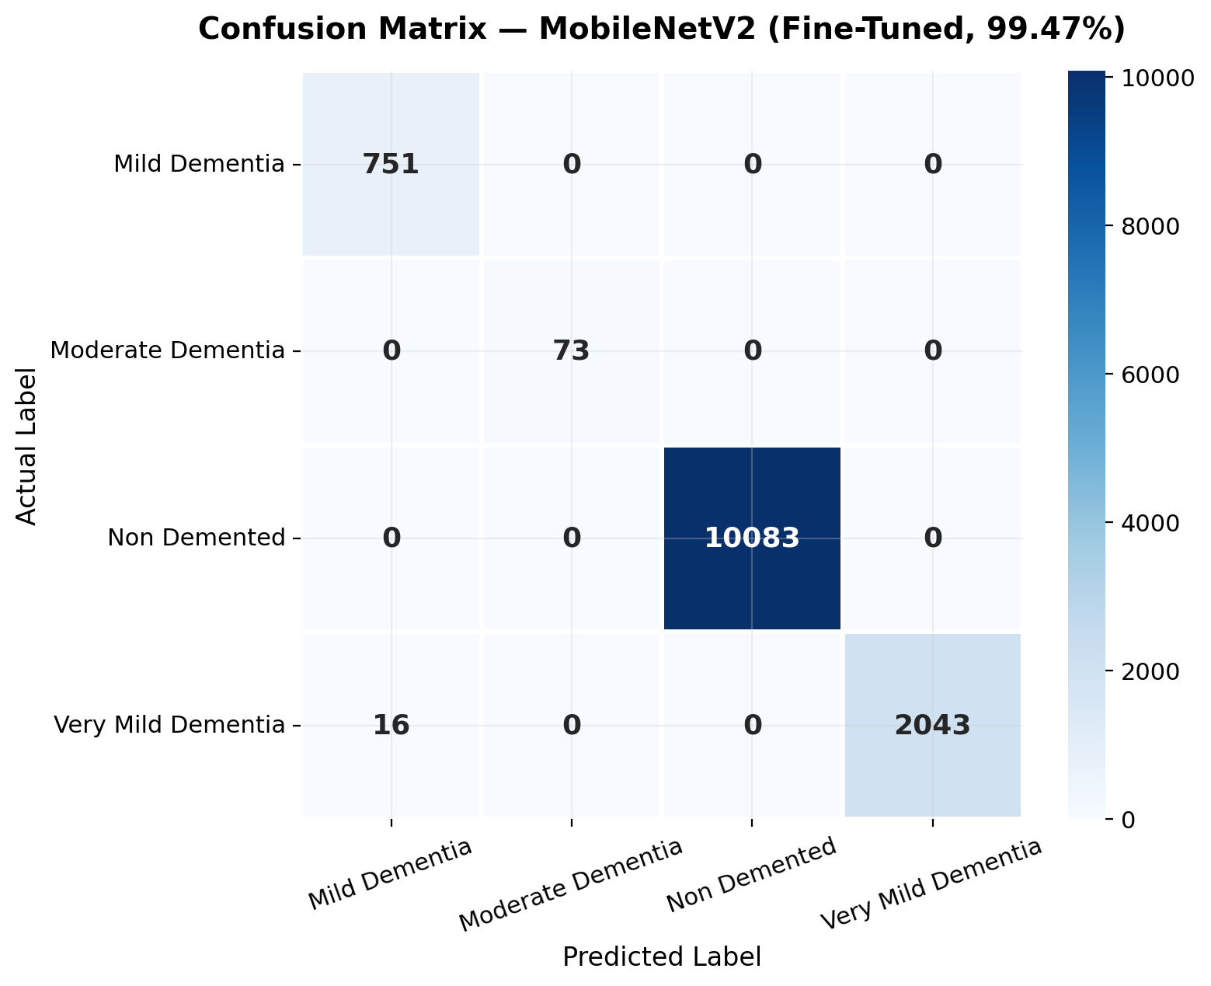

8. Technologies Used
Category | Technology | Purpose
Language | Python 3.12 | Core programming language
Deep Learning | TensorFlow 2.19 / Keras | Model building and training
Pre-trained | MobileNetV2 (ImageNet) | Transfer learning backbone
Image Processing | OpenCV, PIL | Loading and resizing MRI scans
Data Science | NumPy, Pandas | Array operations, dataframes
Visualization | Matplotlib, Seaborn | Plots, confusion matrices
ML Utilities | scikit-learn | Splitting, metrics, class weights
Web Framework | Flask | Backend web application
Database | SQLite3 | User authentication, prediction logs
Security | Werkzeug | Password hashing (PBKDF2-SHA256)
Frontend | HTML5, CSS3, JS | UI templates and interactivity
Training GPU | Google Colab (T4) | GPU-accelerated training
Dataset Source | Kaggle (kagglehub) | Automated data download

9. Web Application
A complete Flask web application provides real-time Alzheimer's detection with user authentication, MRI image upload, model selection, confidence scoring, and detailed clinical context including probable causes and treatment suggestions.

Key Features
- User Registration & Login with secure PBKDF2 password hashing.
- MRI Image Upload supporting JPG/PNG formats (max 16MB).
- Real-time Prediction with per-class probability distribution.
- Clinical Context with detailed probable causes and treatment suggestions.
- Prediction History stored in SQLite database.

Application Routes
Route | Description
/home | Home page with project statistics
/about | Disease information, dataset, technology stack
/register | New user registration
/login | User authentication
/predict | MRI upload and prediction (requires login)
/methodology | ML pipeline and training documentation

Database Schema
Table | Field | Type | Description
users | id | INTEGER PK | Auto-increment primary key
users | full_name | TEXT | User full name
users | email | TEXT UNIQUE | User email address
users | password_hash | TEXT | PBKDF2-SHA256 hashed password
predictions | id | INTEGER PK | Auto-increment primary key
predictions | user_id | INTEGER FK | References users.id
predictions | image_filename | TEXT | Uploaded MRI filename
predictions | model_used | TEXT | Model architecture used
predictions | predicted_class | TEXT | Predicted Alzheimer stage
predictions | confidence | REAL | Prediction confidence (%)

10. Conclusion

Key Findings
- Transfer learning with fine-tuning vastly outperforms training from scratch on medical imaging tasks.
- MobileNetV2 with partial backbone unfreezing achieved 99.47% test accuracy with only 2.6M parameters.
- Input resolution matters: upgrading from 128x128 to 224x224 improved accuracy by +24.20 percentage.
- Models trained from scratch (CNN, MLP) completely failed to converge on this imbalanced dataset.
- The fine-tuned model achieved perfect 1.00 F1-score on the rarest class (Moderate Dementia, only 73 test samples).
- Class weighting effectively addressed the 138:1 imbalance ratio between majority and minority classes.

Limitations
- The model is trained on a single dataset (OASIS) and should be validated externally before clinical use.
- MRI preprocessing (skull stripping, normalization) was not applied, which could further improve performance.

Future Work
- Implement Grad-CAM visualization to show which brain regions influence predictions.
- Add support for 3D volumetric MRI analysis (currently using 2D slices).
- Validate on external datasets (ADNI, MIRIAD) for clinical robustness.

11. References
[1] OASIS Dataset: https://www.oasis-brains.org/
[2] Kaggle Dataset: https://www.kaggle.com/datasets/ninadaithal/imagesoasis
[3] MobileNetV2: Sandler et al., 'MobileNetV2: Inverted Residuals and Linear Bottlenecks', CVPR 2018.
[4] VGG16: Simonyan & Zisserman, 'Very Deep Convolutional Networks for Large-Scale Image Recognition', ICLR 2015.
[5] ResNet50: He et al., 'Deep Residual Learning for Image Recognition', CVPR 2016.
[6] EfficientNet: Tan & Le, 'EfficientNet: Rethinking Model Scaling for CNNs', ICML 2019.
[7] TensorFlow: https://www.tensorflow.org/
[8] Flask: https://flask.palletsprojects.com/

